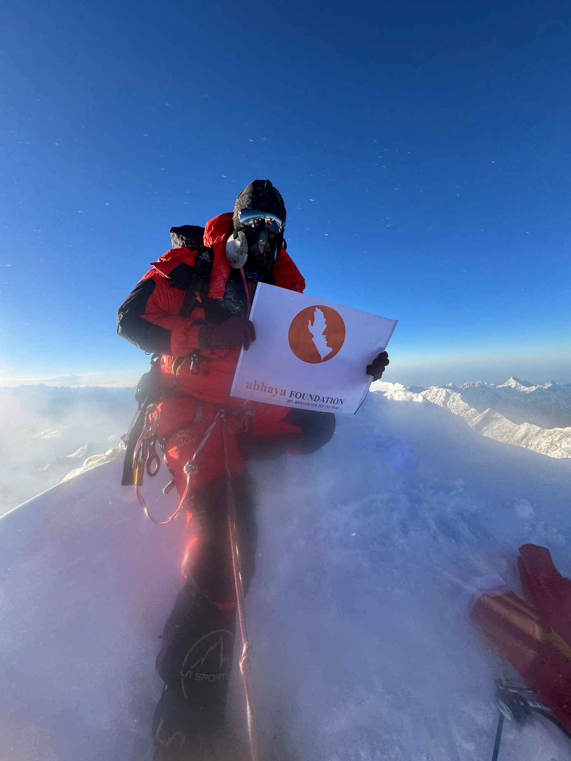Conquering Shishapangma: A Testament to Resilience and Kindness

On October 1st, I embarked on my Tibet expedition via the Kyrung border, only to be halted by a massive landslide. Undeterred, I flew to Lhasa on October 4th and reached basecamp by October 6th.

Racing against time, I skipped Camp 1 to catch up with my team, but my Sherpa fell ill due to inadequate acclimatization. With the summit window closing in, I made the bold decision to proceed solo, leveraging my years of experience.

At midnight, I began my ascent, braving -30°C temperatures and treacherous terrain. After 8 grueling hours, I stood triumphant atop Shishapangma, completing 7 death zone peaks!

None of this would have been possible without abhaya's timely support with my paperwork. I proudly hoisted the abhaya flag on the summit, symbolizing gratitude and kindness. To all abhayans, let's spread kindness and inspire others! - Bharat Thammineni, abhaya SoulDear, Hyderabads