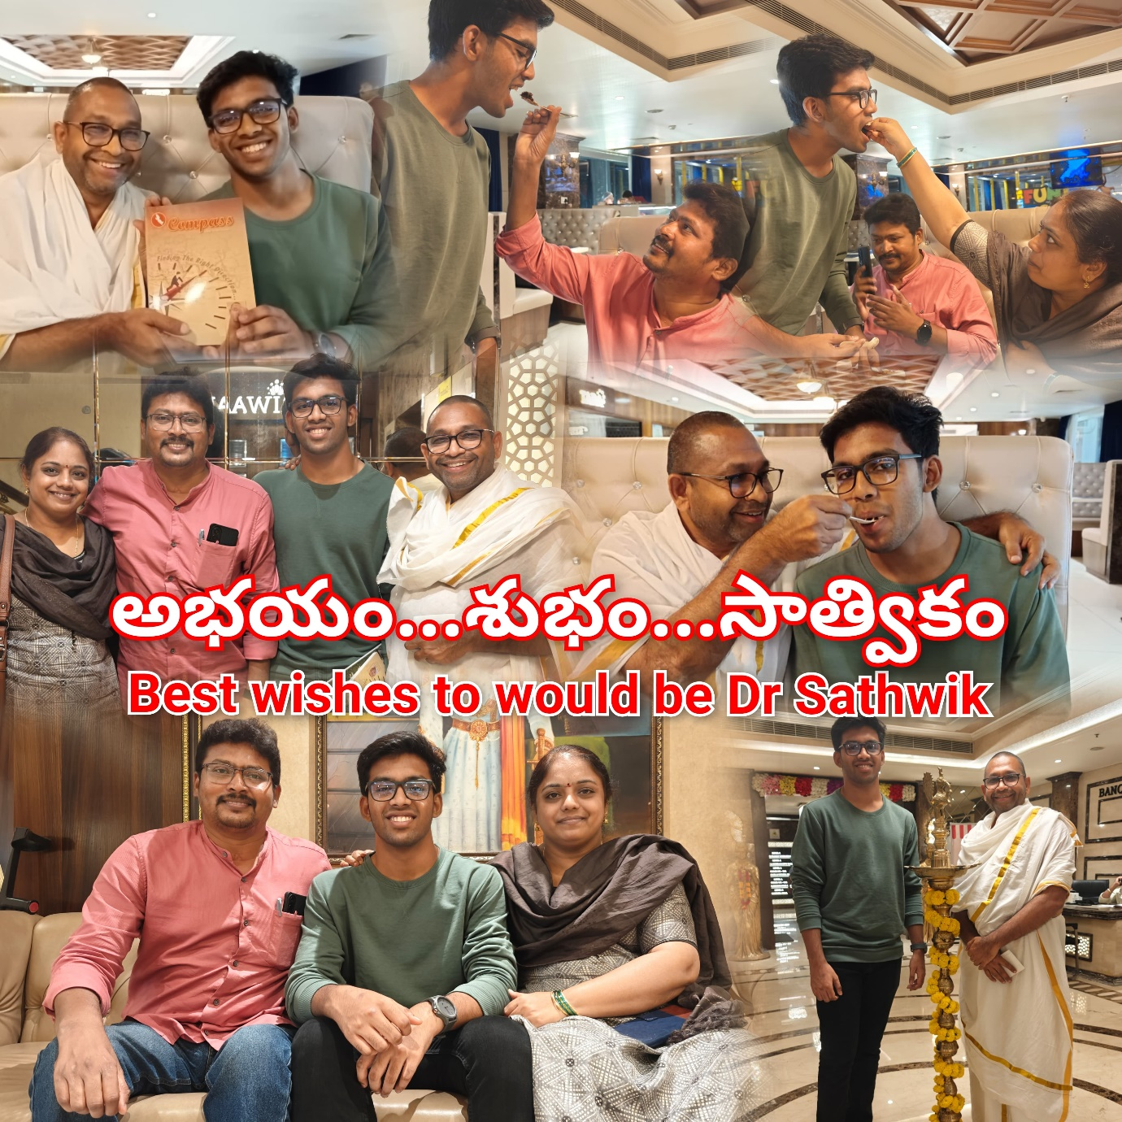abhaya congratulate (Dr) Sathwik & Thank parents for the kind Donation

Heartfelt congratulations to the would be Dr. Sathwik on his admission to the MBBS program at Medicity College, Medchal, Hyderabad.

Sathwik's remarkable journey serves as an inspiration to all abhaya SoulDears. Born to parents who once faced numerous challenges, he has emerged as a shining beacon of hope and pride in their lives.

A true embodiment of abhaya spirit, Sathwik's family (Dr Mrudula & Parthu) has transformed from beneficiaries to benefactors. Their kindness and continuous support to the cause are deeply appreciated.

In celebration of this milestone, Dr Mrudula Parthu generously donated ₹25,000, paving the way for others to follow in his footsteps.

May Sathwik's achievement motivate and inspire every abhaya SoulDear to strive for excellence.

Best wishes to the would be Dr. Sathwik on his medical journey!

With lots & loads of Love

Balachandra