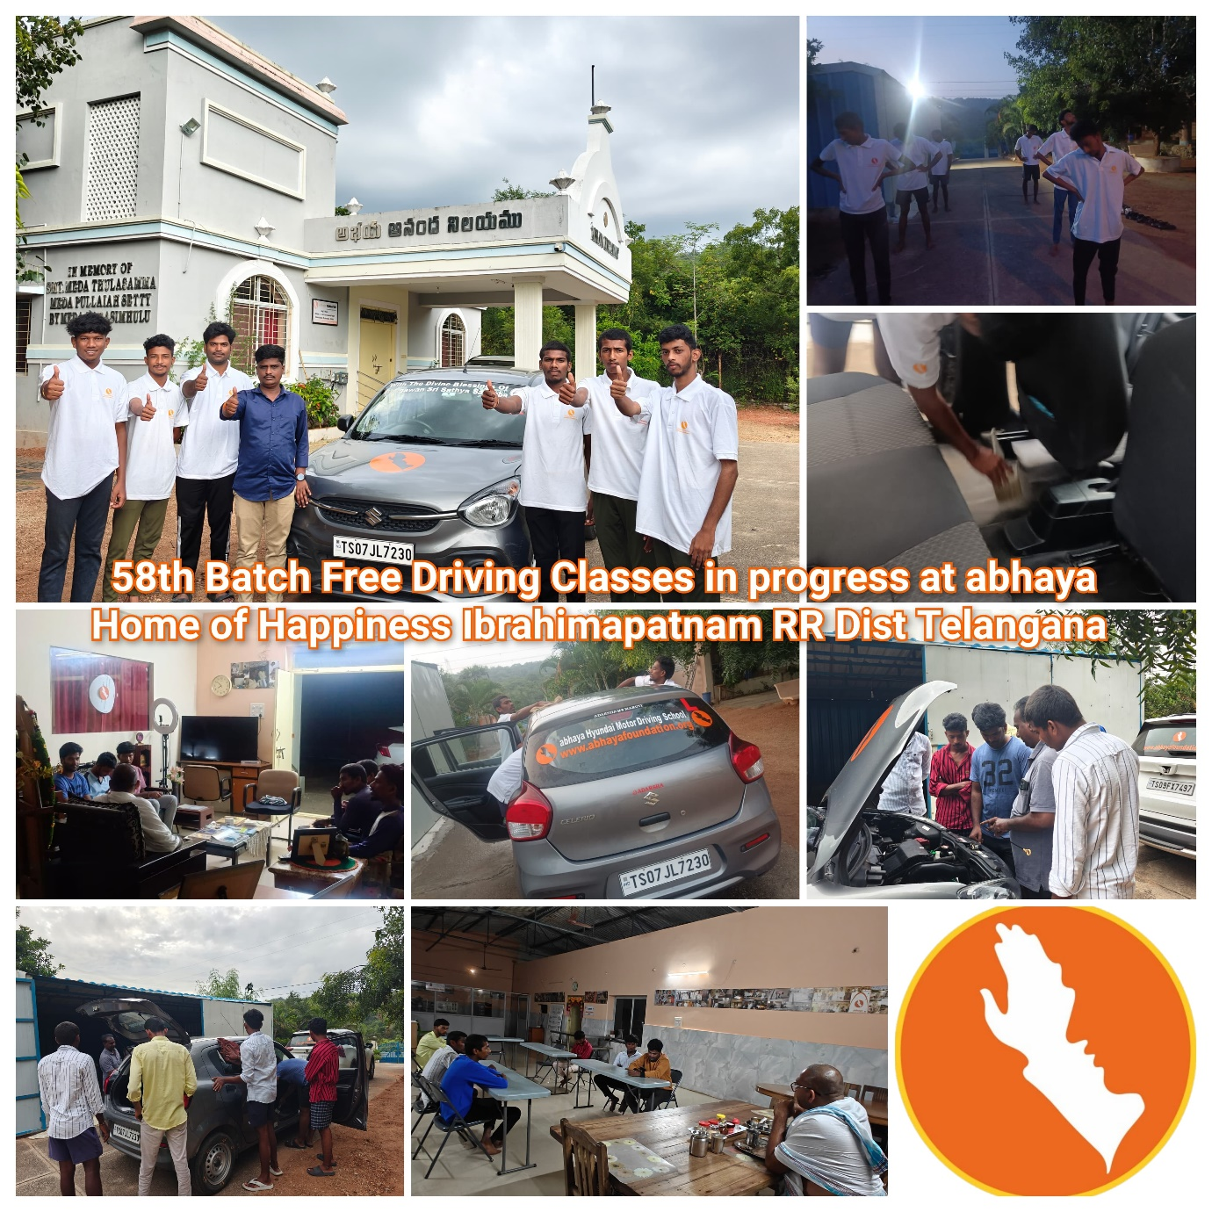For Free Residential Driving Classes:

Golden opportunity to unemployed/ uneducated youth in South India.

Please Call & register. The classes will start from 1st November 2024.

Bhargav, Anantapuram (9701241487),

Manga, Hyderabad (9515823052),

Kranthi, Khammam (99082 97973),

Sanjay, Blore (97404 50950)

www.abhayafoundation.org