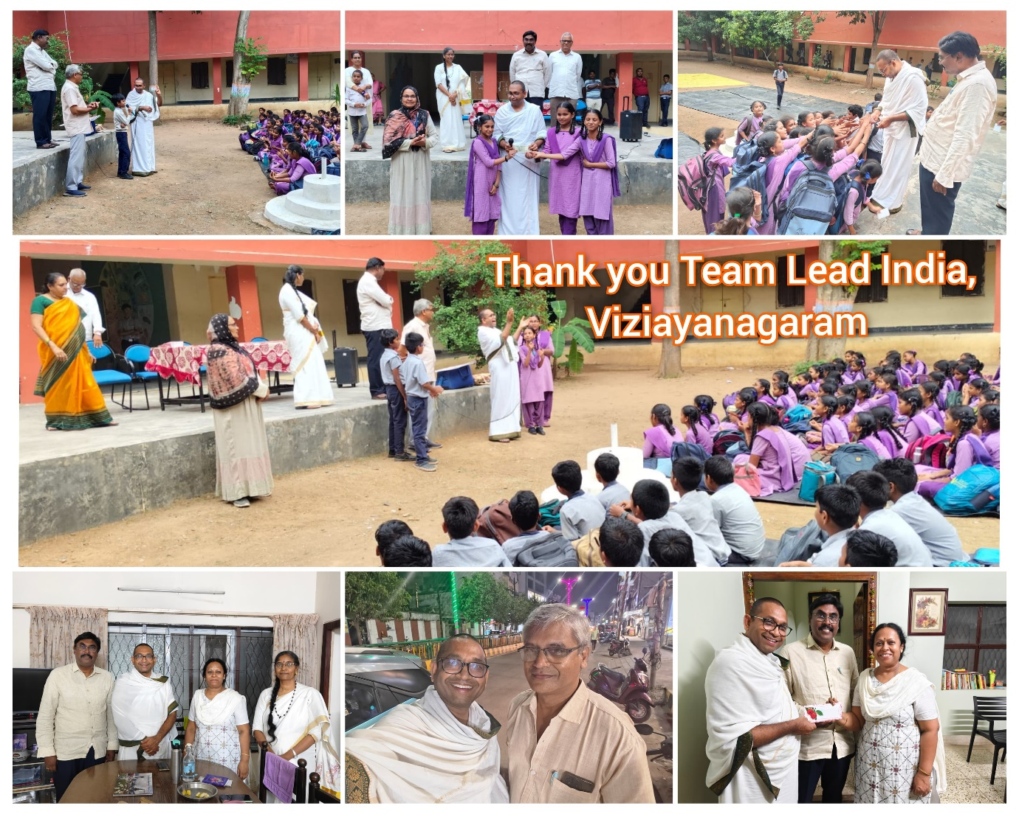I extend my heartfelt gratitude to Team Lead India for their exceptional hospitality and support during my visit to Vizianagaram, AP. Their selfless dedication to serving the community is truly inspiring.

Specifically, I thank CA Balaji for arranging transportation and accompanying me to Centurian University, AP Model School, and KGBV and showcasing extraordinary care and attention to every detail, making me feel like family

I also deeply appreciate Uma Balaji for warmly hosting me at their residence, providing delicious meals and generously donating to abhaya cause

Their kindness and generosity have left an indelible mark on my heart. I offer my sincerest thanks to CS Rao, Jagadeesh, Indumani, Siva and Uma Balaji for the remarkable warmth and commitment to making a difference.

Their compassion and humility are a beacon of hope, inspiring us all to strive for a better world. - with ❤ Balachandra