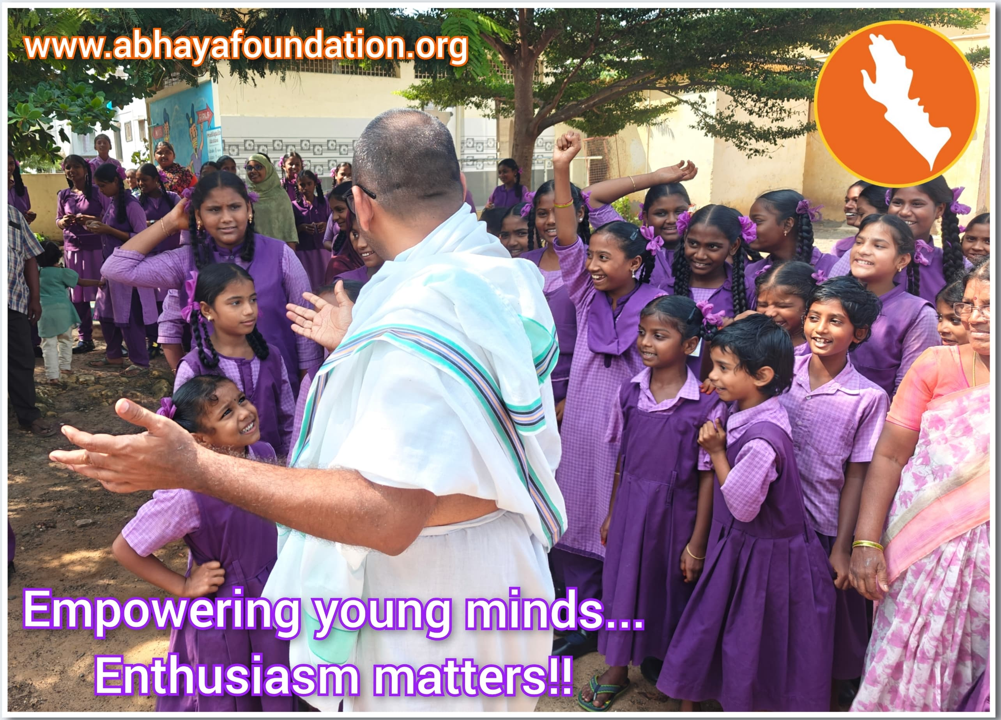Sunday Thoughts: Empowering Young Minds... Enthusiasm Matters!!

Dear friends! Creating enthusiasm in nurturing and developing young minds, particularly in government schools, is urgently needed! As it: Fosters a love for learning, Inspires students to become motivated, Fosters creativity and curiosity, and improves academic performance.

I urge everyone to visit nearby schools and create enthusiasm among the kids. Miracles will surely happen.- Balachandra 🤗✊🏻✌🏻👍🏻