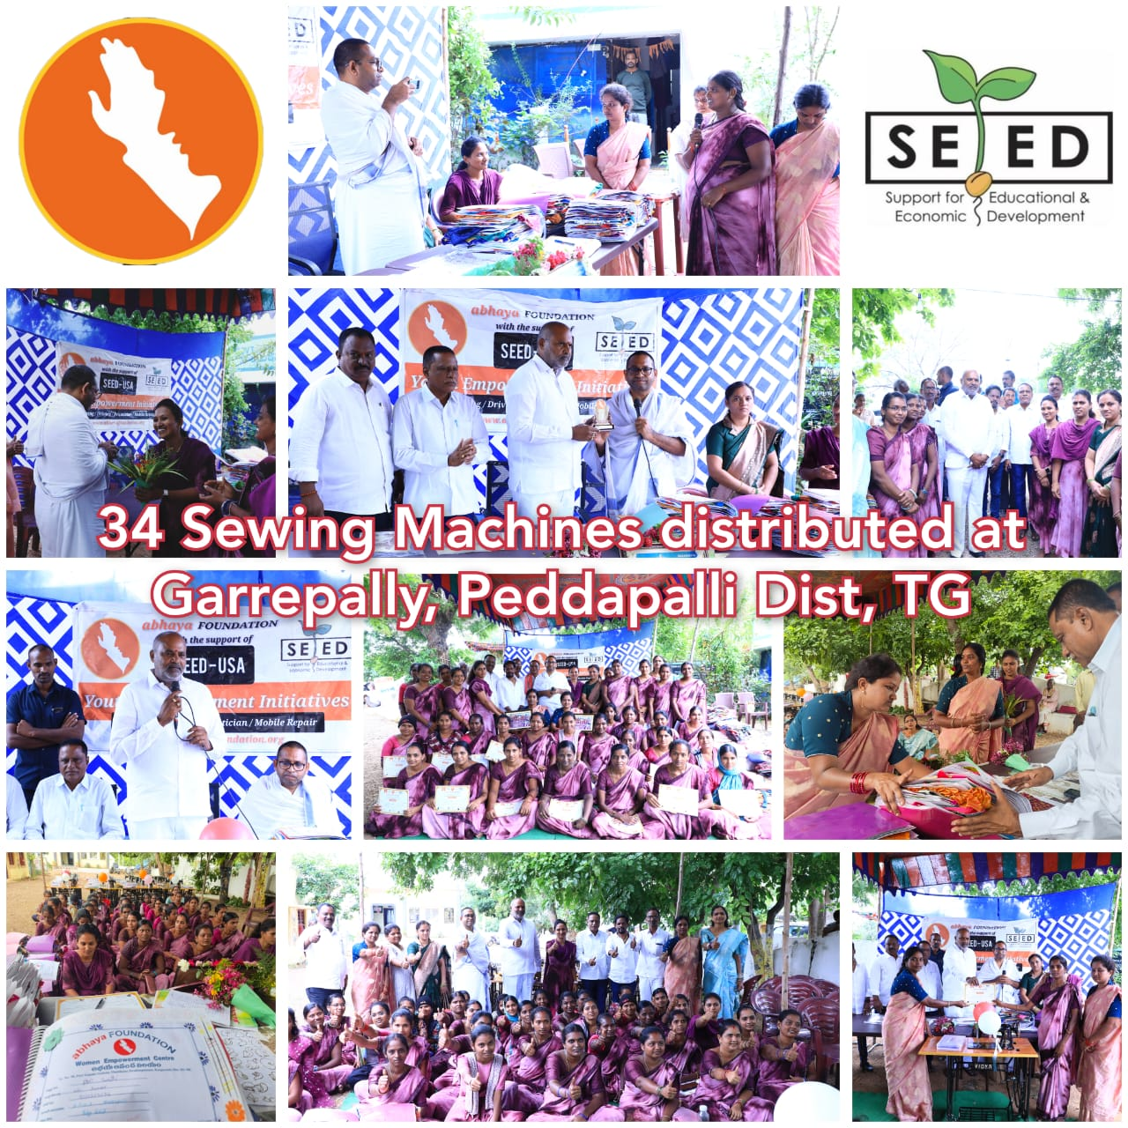

Sri Vijaya Ramana Rao, MLA, Peddapalli graced the event and appreciated the good work done by abhaya Foundation in his constituency. He also wanted to explore giving Compass Books to the students of his constituency. - Team abhaya