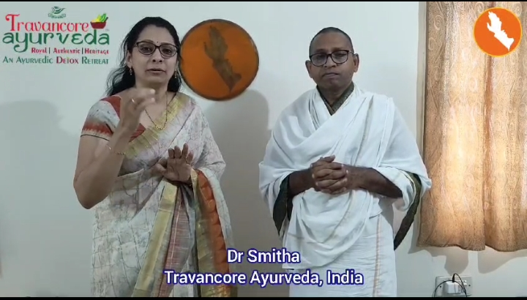

Dear Friends! Encourage all the unemployed/ uneducated young men / women to take this course. They may earn 15 - 20K PM happily in Bengaluru/ Vizag/Hyderabad. Placement assured after training. Share it max... Balachandra