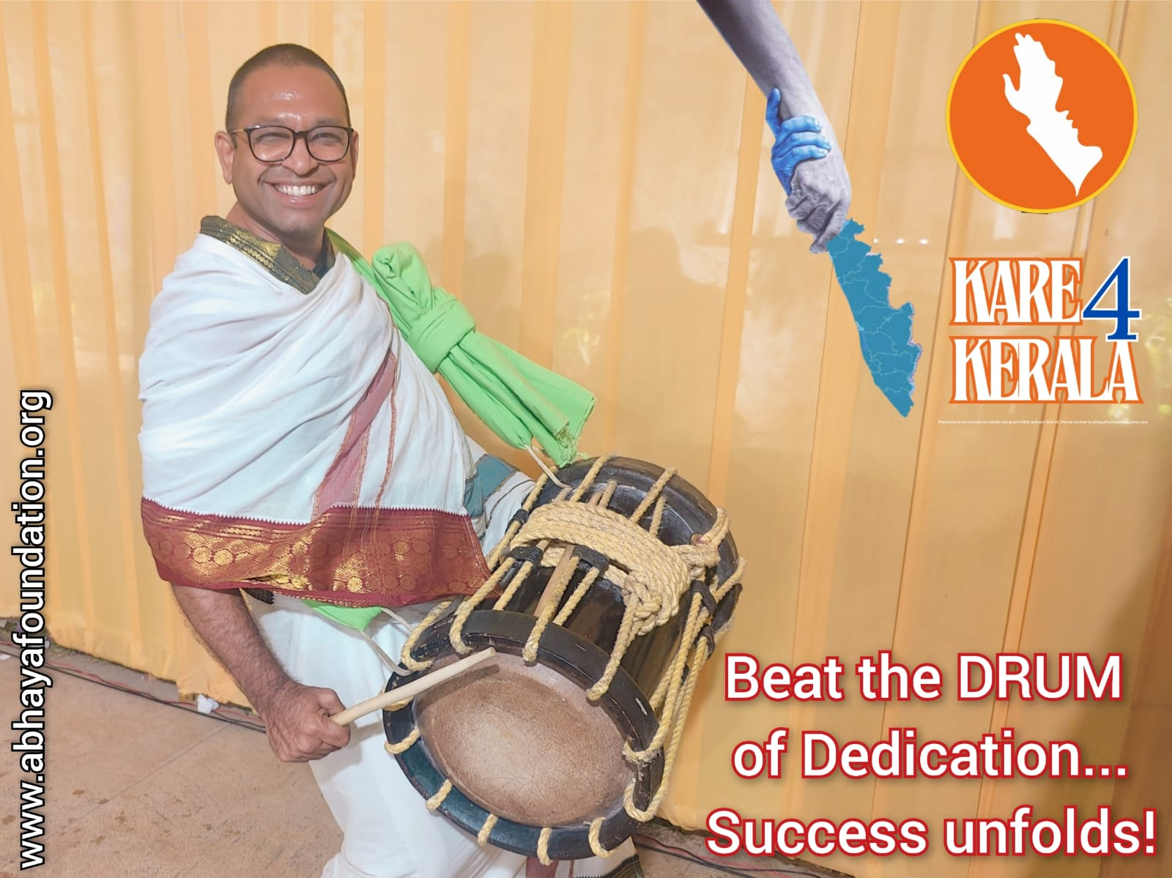Sunday Thoughts: Beat the DRUM of Dedication...Success unfolds!

Dedication is the catalyst for success. When we consistently beat the drum of dedication, we create a rhythm of hard work, persistence, and resilience. This rhythm sets in motion a chain of events that ultimately leads to success unfolding in our life. This is the story of Kare4Kerala through which abhayans proved it once again. I take a bow before 600 SoulDears who together pooled Rs.12,00,000/- in just 10 days. Happy Times ahead! - Balachandra