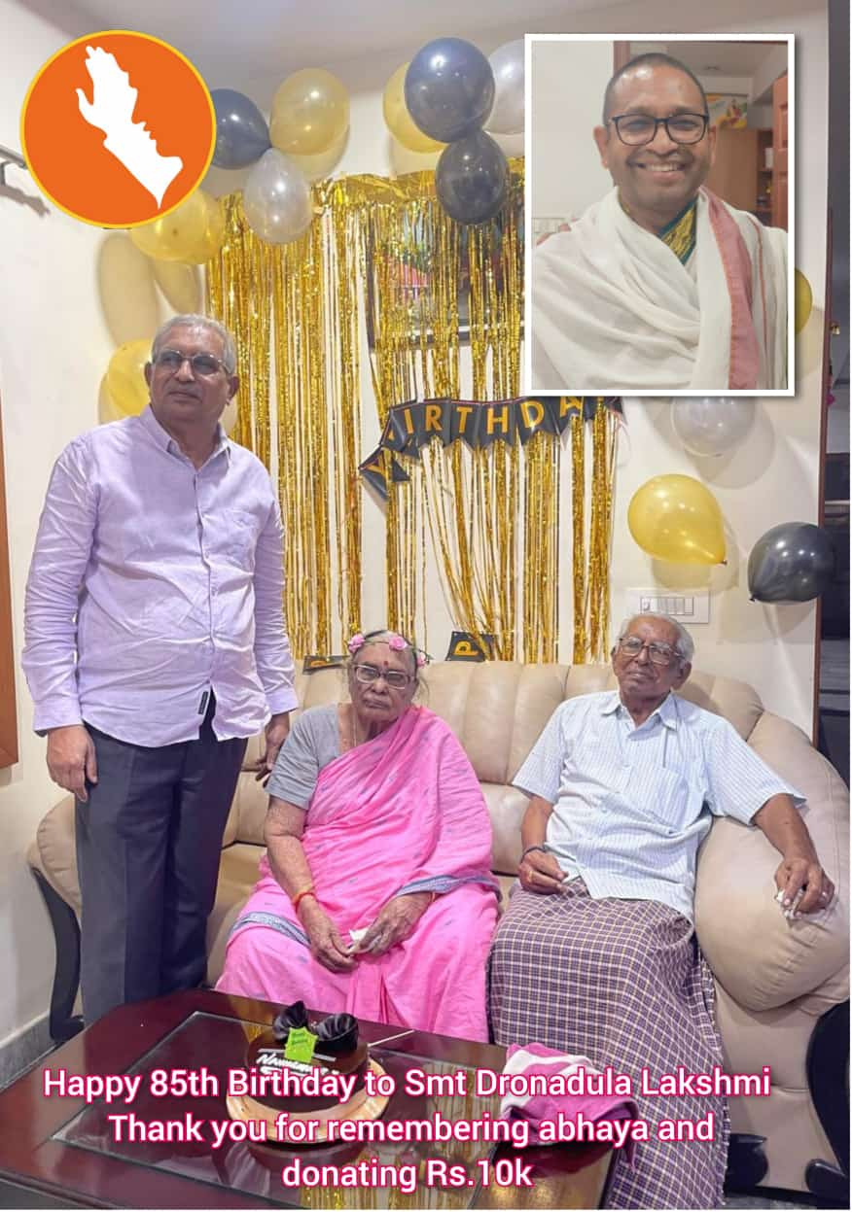

26.08.2024/930PM: abhaya Board Member Sri D Vijaya Bhaskar, Former OL, AP and presently Advocate, shared news that his Mother and her Brother are celebrating Birthday today. I said Wow!!! asked him whether I can have a video call with them. He is kind enough to say yes. I called and sang Birthday Song for them. But, to my utter surprise, she said, she will donate Rs.10K to abhaya. He said, mother was remembering me and abhaya...I called her on video. Don't know what to say about this. I am feeling blessed by such people remembering abhaya on their special days. Long live kindness! Long live Love for the fellow beings. - 💗🙏 Balachandras