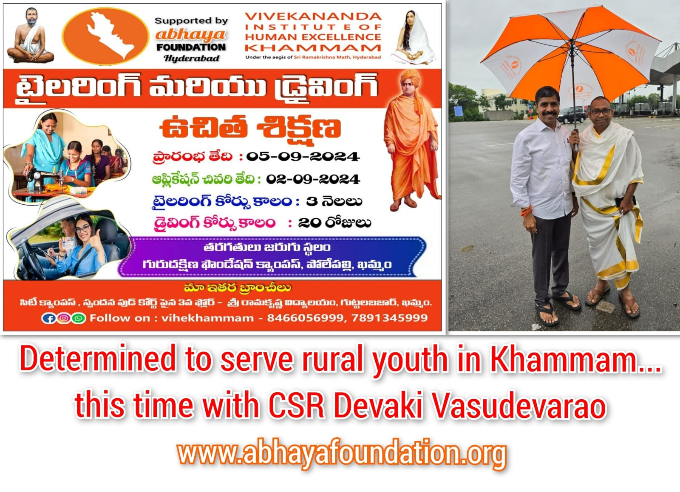

Profession is CS...Passion is Service!! This is the story of beloved CS Devaki Vasudevarao, Hyderabad. He, while practicing as Company Secretary...he has been serving the communities at Khammam for the past one and half decades. Today we together with abhaya & VIHE launching empowerment initiatives to provide Livelihood Skills and Life Skills to 100 Rural unemployed youth. Very happy to see his passion, compassion and innovation. Long live serving attitude. Jayho! 🤗🫶🏻👏🏻👏🏻👏🏻 - Balachandra